**Assignment 3:**

→ Clone an existing repository on Github created during course and configure your local repo to point to the remote repository

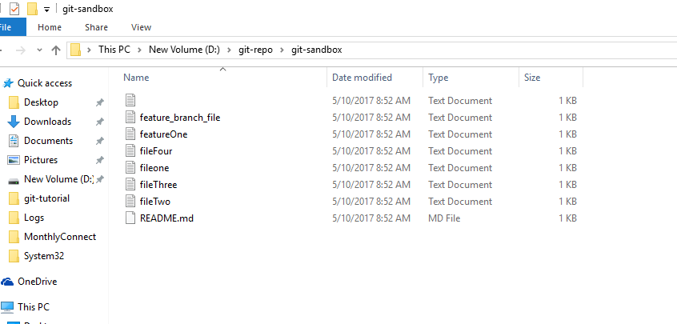

→ Perform some operation like add, remove, modify and finally push your changes to the remote repository

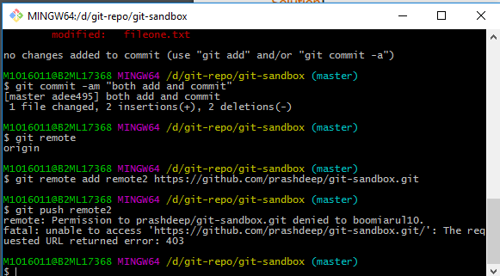

**Please Note**: I don’t have permission to push the changes to remote repository.

→ Pull the latest changes from the repository to get the updates from others in to your local repo and merge the changes

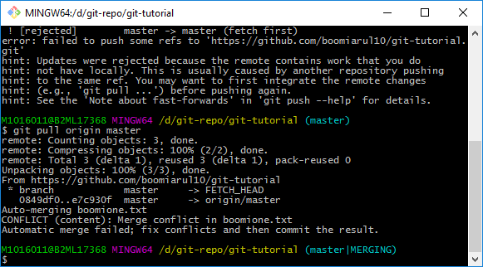

→ Try fetching the changes and perform the merge to get the difference between the pull and the merge command

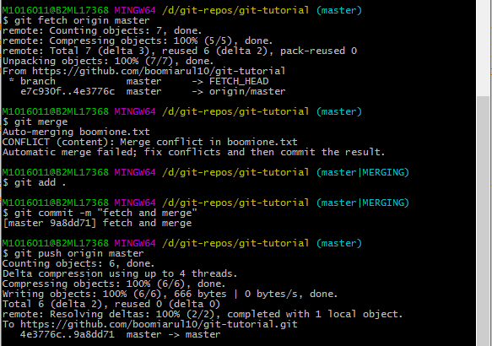

→ Perform some changes and before committing the changes, stash your changes and then pull the changes and finally apply the changes to understand how stashing works

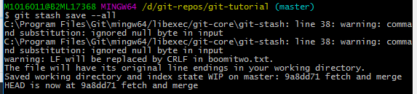

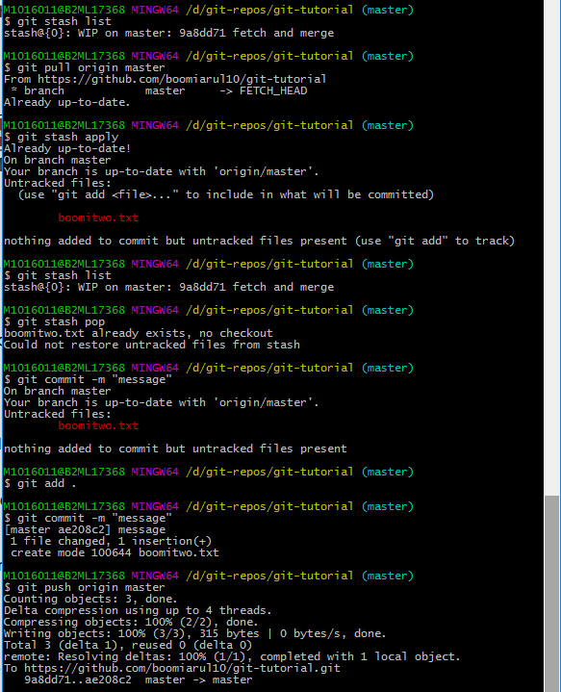

→ Create a feature branch and do some file operations in the branch and commit the changes to the branch

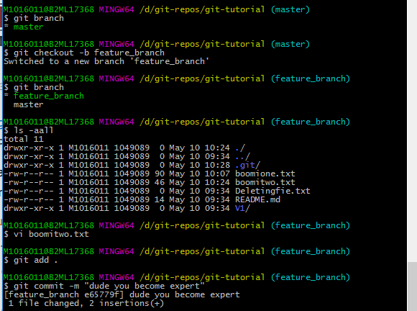

→ Create another feature branch and this time after committing the changes to the feature branch, merge the changes using fast forward merge and then delete the feature branch

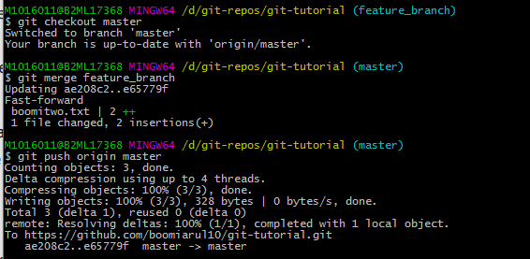



→ Merge the changes using the rebase command and finally perform a safe deletion of the feature branch

